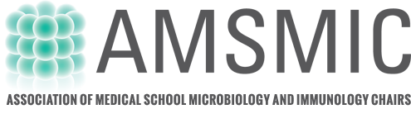

WELCOME
On behalf of the Program Committee, I would like to welcome you to the 19th AMSMIC Workshop. This biennial workshop was developed and sponsored by the Association of Medical Schools Microbiology and Immunology Chairs (AMSMIC) in 1986. The focus of the meeting is sharing best practices in Microbiology and Immunology education in medical schools with the objective to help train the next generation of teachers and leaders in Microbiology and Immunology education.
The Workshop will enable the sharing of innovative strategies in Microbiology and Immunology teaching through facilitated group discussions, poster sessions, short oral presentations and informal networking.
We have assembled what we think is a fantastic program with a scientific Keynote talks. We are also very excited that the meeting includes oral and poster presentations from our participants! We hope that this meeting format provides for robust discussion and the development of future collaborations and educational scholarship!

Julie Kerry, Chair AMSMIC Education Committee
Eastern Virginia Medical School

Program Committee
Tim Bauler, West Michigan University
Neal Chamberlain, A.T. Still University
Rebecca Greenblatt, SUNY Upstate Medical University
Brian Higgins, University of Kentucky

www.amsmic.org
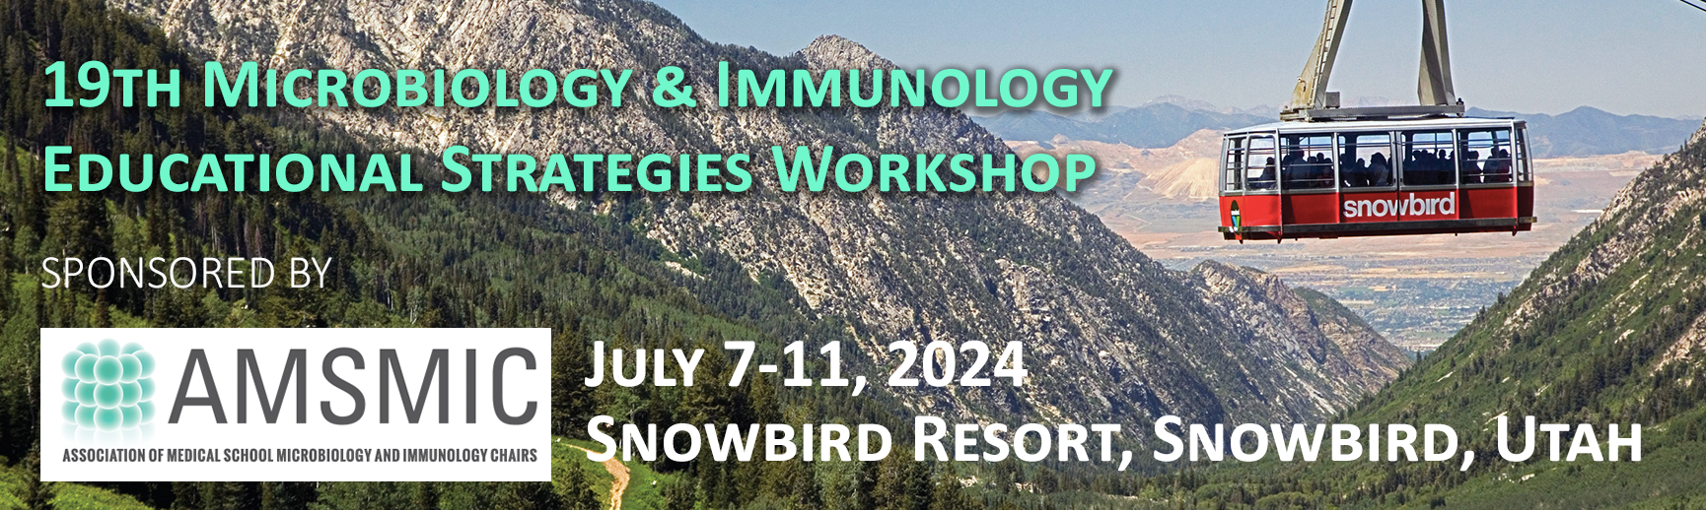

Sunday July 7 - Welcome
3:00 – 6:00 pm AMSMIC Registration Desk Open

6:30 – 9:00 pm Welcome Reception & Dinner

Monday July 8 –
8:00 - 5:00 pm AMSMIC Desk Open

8:45 – 9:00 am Welcome & Introductions
Julie Kerry
9:00 – 10:00 am Keynote: Scientific Talk

10:00 - 10:30 am Break

10:30 – 11:30 am Facilitated Discussion: Shortening the Curriculum - Dumbing Down or Career Appropriate?

12:00 – 1:30 pm Lunch (Included)

1:30 - 3:15 pm Short Talks
3:15 - 3:45 pm Break / Poster Set-Up

3:45 - 5:45 pm Micro Teaching: Quick and fun learning ideas or tools!
1-2 slide Presentations

PM Evening Free

Tuesday July 9 –

9:00 - 10:30 am: Workshop: Backflip Teaching: Before, During and After

- Using Video for Active Learning

- PPT – the good and the bad

- Making Homework Cool Again

10:30 - 11:00 am Break

11:00 - 12:00 pm: Facilitated Discussion: Impact of Step 1 Timing on the Microbiology and Immunology Curriculum

12:00 - 1:30 pm Lunch (included)

1:30 - 2:30 pm Short Talks:

2:30 - 3:00 pm Break

3:00 - 5:00 pm Short talks:

7:00 - 9:00 pm Optional Working Dinner: Microbiology Learning Objectives for the Preclerkship Phase
Must be pre-registered

PM Evening Free

Wednesday July 10 – Faculty Development

9:00 - am Keynote/Workshop – How to be an Effective Course Director in an Integrated or a Stand-Alone Micro/Immuno Course

10:30 - 11:00 am Break

11:00 - 12:00 pm: Facilitated Discussion: Perils, Pitfalls and Successes in Course Directing

12:00 - 1:30 pm Lunch (included)

1:30 - 2:30 pm Breakout Discussions:
Thriving in the First five years
Maintaining Mid-Career motivation
Finishing Strong!

2:30 – 3:45 pm Reports from Breakout Groups and General Discussion

3:45 - 4:00 pm Closing Remarks
Julie Kerry

6:30 - 9:00 pm Farewell Dinner (Included)

